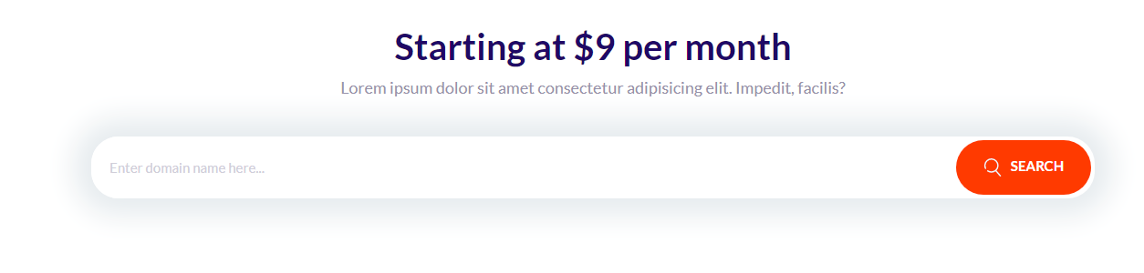
Today I learned about domain blocks I made them using HTML and CSS. domain blocks are blocks that contain an input, a button, and a header.

